**NYU Tandon School of Engineering**

**Fall 2022, ECE 6913**

**Homework Assignment 4**

*Instructor: Azeez Bhavnagarwala,* email: [ajb20@nyu.edu](mailto:ajb20@nyu.edu)

*Course Assistants*

Varadraj Kakodkar (vns2008), Kartikay Kaushik (kk4332), Siddhanth Iyer (si2152), Swarnashri Chandrashekar (sc8781), Karan Sheth (kk4332), Haotian Zheng (hz2687), Haoren Zhang (kk4332), Varun Kumar (vs2411)

**Homework Assignment 4** [released Wednesday October 5th 2022] [due Wednesday October 12th by 11:59PM]

You *are allowed* to discuss HW assignments with anyone. You are *not allowed* to share your solutions with other colleagues in the class. Please feel free to reach out to the Course Assistants or the Instructor during office hours or by appointment if you need any help with the HW.

Please enter your responses in this Word document after you download it from NYU Classes. *Please use the Brightspace portal to upload your completed HW.*

**1.** How would you test for overflow, the result of an addition of two 8-bit operands if the operands were (i) unsigned (ii) signed with 2s complement representation.

Add the following 8-bit strings assuming they are (i) *unsigned* (ii) *signed and represented using 2’s complement*. Indicate *which of these additions overflow*.

A. 0110 1110 + 1001 1111

B. 1111 1111 + 0000 0001

C. 1000 0000 + 0111 1111

D. 0111 0001 + 0000 1111

**2.** One possible performance enhancement is to do a shift and add instead of an actual multiplication. Since 9×6, for example, can be written (2×2×2+1)×6, we can calculate 9×6 by shifting 6 to the left three times and then adding 6 to that result. Show the best way to calculate 0xABhex × 0xEFhex using shifts and adds/subtracts. Assume both inputs are 8-bit unsigned integers.

**3.** What decimal number does the 32-bit pattern 0×DEADBEEF represent if it is a floating-point number? Use the IEEE 754 standard

**4.** Write down the binary representation of the decimal number 78.75 assuming the IEEE 754 *single precision* format. Write down the binary representation of the decimal number 78.75 assuming the IEEE 754 *double precision* format

**5.** Write down the binary representation of the decimal number 78.75 assuming it was stored using the single precision **IBM format** (base 16, instead of base 2, with 7 bits of exponent).

**6.** IEEE 754-2008 contains a half precision that is only 16 bits wide. The leftmost bit is still the sign bit, the exponent is 5 bits wide and has a bias of 15, and the mantissa (fractional field) is 10 bits long. A hidden 1 is assumed.

(a) Write down the bit pattern to represent **−1.3625 ×10−1** Comment on how the range and accuracy of this 16-bit floating point format compares to the single precision IEEE 754 standard.

(b) Calculate the sum of **1.6125 ×101** (A) and **3.150390625** ×10−1 (B) by hand, assuming operands A and B are stored in the 16- bit half precision described in problem a. above Assume 1 guard, 1 round bit, and 1 sticky bit, and round to the nearest even. Show all the steps.

**7.** What is the range of representation and relative accuracy of positive numbers for the following 3 formats:

(i) IEEE 754 Single Precision (ii) IEEE 754 – 2008 (described in Problem 6 above) and (iii) ‘bfloat16’ shown in the figure below

IEEE 754, Single Precision:



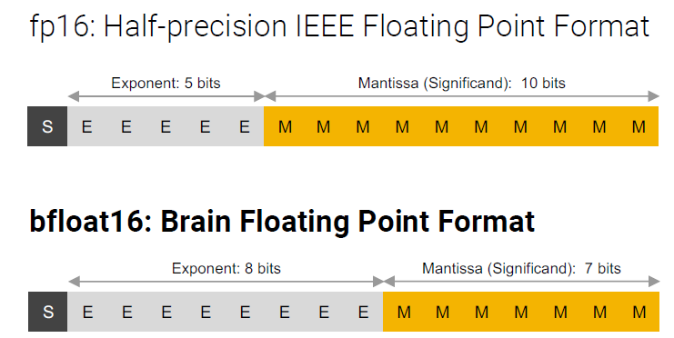

**8.** Suppose we have a 7-bit computer that uses IEEE floating-point arithmetic where a floating point number has 1 sign bit, 3 exponent bits, and 3 fraction bits. All of the bits in the hardware work properly.

Recall that denormalized numbers will have an exponent of 000, and the bias for a 3-bit exponent is

23-1 – 1 = 3.

**(a)** For each of the following, write the *binary value* and *the corresponding decimal value* of the 7-bit floating point number that is the closest available representation of the requested number. If rounding is necessary use round-to-nearest. Give the decimal values either as whole numbers or fractions. The first few lines are filled in for you.

|  |  |  |
| --- | --- | --- |
| **Number** | **Binary** | **Decimal** |
| 0 | 0 000 000 | 0.0 |
| -0.125 | 1 000 000 | -0.125 |
| Smallest positive normalized number |  |  |
| largest positive normalized number |  |  |
| Smallest positive denormalized number > 0 |  |  |
| largest positive denormalized number > 0 |  |  |

**(b)** The associative law for addition says that a + (b + c) = (a + b) + c. This holds for regular arithmetic, but does not always hold for floating-point numbers. Using the 7-bit floating-point system described above, give an example of three floating-point numbers a, b, and c for which the associative law does not hold, and show why the law does not hold for those three numbers.